**Task #1**

The table below is the time it took to run “ConjugateGradient()” without any changes.

**One Thread** was specified here. **Four Thread** was specified here.

|  |
| --- |
| Initialization : 34.8622ms |
| ComputeLaplacian on line 2: 170.5ms |
| Saxpy on line 2: 78.314ms |
| Norm on line 2: 102.779ms |
| Copy on line 4: 64.238ms |
| InnerProduct on line 4: 61.8256ms |
| ComputeLaplacian on line 6: 41028.4ms |
| InnerProduct on line 6: 16759.5ms |
| Saxpy on line 8: 17653.6ms |
| Norm on line 8: 26433.3ms |
| Saxpy on line 9-12: 76.7118ms |
| Copy on line 13: 10699.8ms |
| InnerProduct on line 13: 16860.1ms |
| 1st Saxpy on line 16: 16762.8ms |
| 2nd Saxpy on line 16: 16928.4ms |
| Total Gradiant Time : 163681ms |

|  |
| --- |
| Initialization : 35.6503ms |
| ComputeLaplacian on line 2: 46.0922ms |
| Saxpy on line 2: 77.3053ms |
| Norm on line 2: 27.5974ms |
| Copy on line 4: 16.2352ms |
| InnerProduct on line 4: 15.0856ms |
| ComputeLaplacian on line 6: 11220.3ms |
| InnerProduct on line 6: 4700.88ms |
| Saxpy on line 8: 16707.4ms |
| Norm on line 8: 7128.03ms |
| Saxpy on line 9-12: 75.2244ms |
| Copy on line 13: 2971.49ms |
| InnerProduct on line 13: 4734.34ms |
| 1st Saxpy on line 16: 16697.5ms |
| 2nd Saxpy on line 16: 16636.1ms |
| Total Gradiant Time : 81054.7ms |

The table below is the time it took to run “ConjugateGradient()” without any changes.

To get this result I implemented a timer for each Kernel and the code looks like the following:  
**lapTimerTotal.Start(); ComputeLaplacian(x, z); lapTimerTotal.Pause();**

Where lapTimerTotal is the timer for ComputeLaplacian kernel.

**Task #2**

The table below is the time it took to run ”ConjugateGradient()” with the following lines combined:

Algorithem Line 2:

Combined the following: ComputeLaplacian, Saxpy, Norm (kernels must be in order written)

Code:

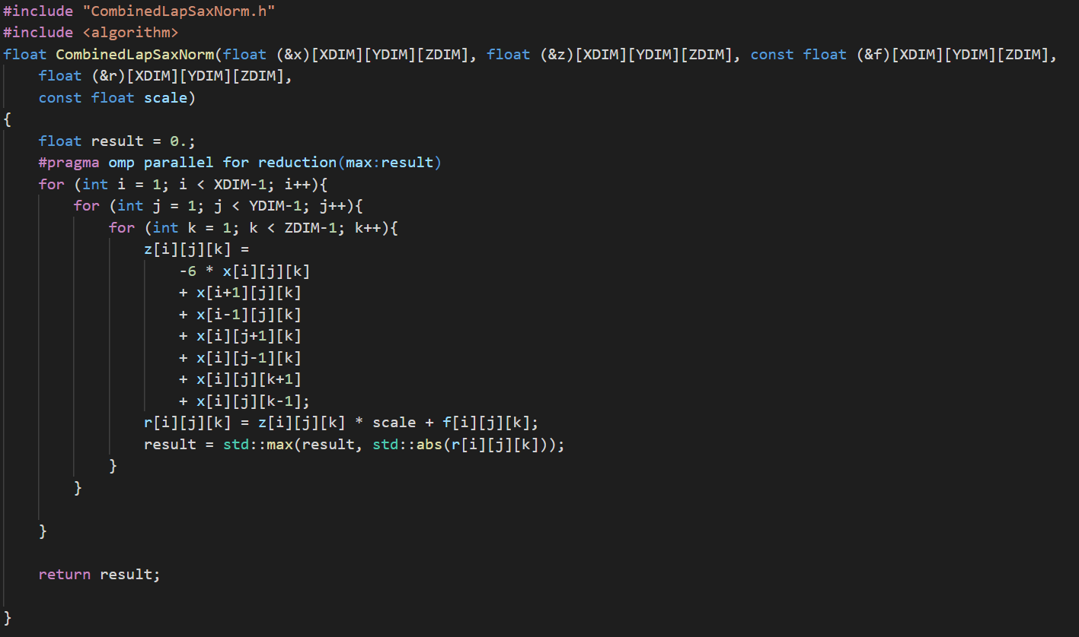

Algorithem Line 4 And 13:

Combined the following: Copy, InnerProduct (kernels must be in order written)

Code:

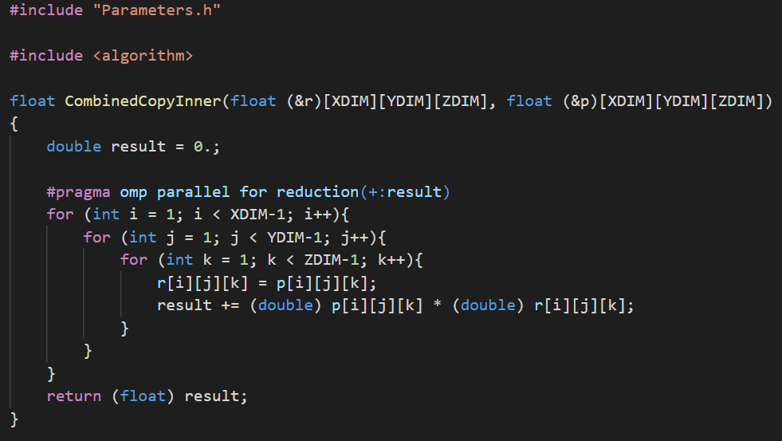

Algorithem Line 6:

Combined the following: ComputeLaplacian, InnerProduct (kernels must be in order written) Code: 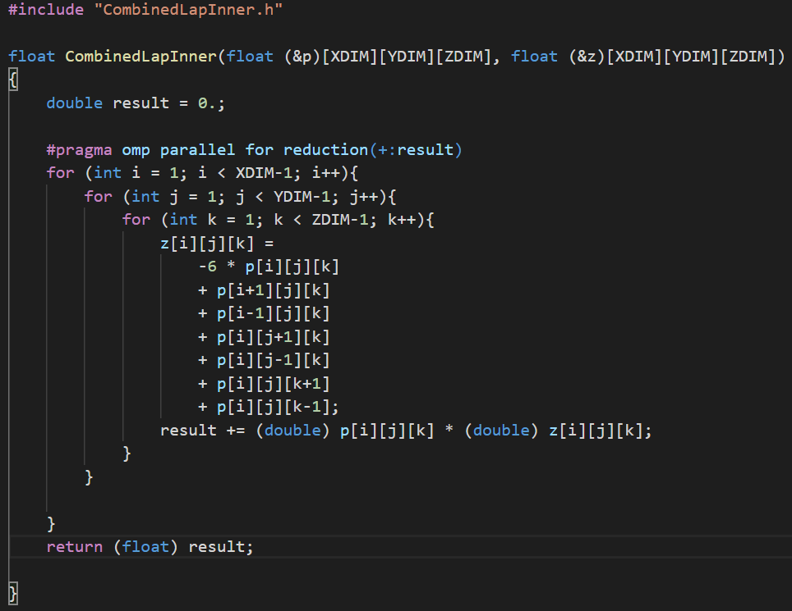

Algorithem Line 8:

Combined the following: Saxpy, Norm (kernels must be in order written)

Code:

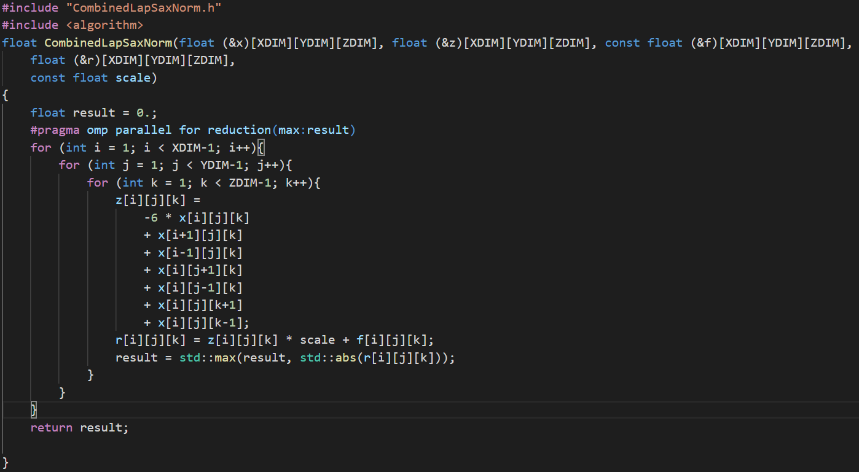

Algorithem Line 16:

Combined the following: Saxpy, Saxpy (kernels must be in order written)

Code:

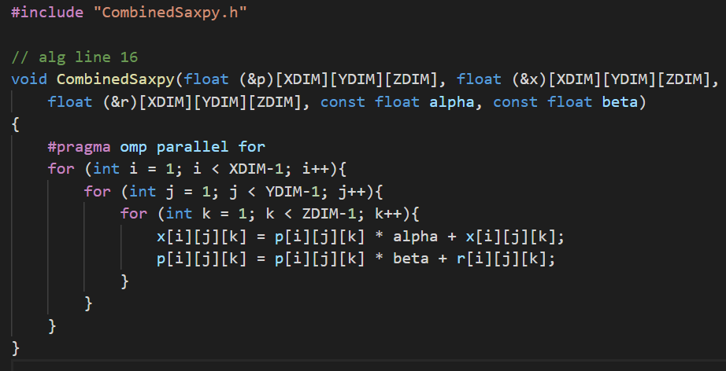

**One Thread** was specified here.  **Four Thread** was specified here

|  |
| --- |
| Initialization : 35.2429ms |
| CombinedLapSaxNorm on line 2: 373.764ms |
| CombinedCopyInner on line 4: 104.413ms |
| CombinedLapInner on line 6: 62187.2ms |
| CombinedSaxNorm on line 8: 43329.5ms |
| Saxpy on line 9-12: 74.9815ms |
| CombinedCopyInner on line 13: 25085ms |
| CombinedSaxpy on line 16: 32735.5ms |
| Total Gradiant Time : 163891ms |

|  |
| --- |
| Initialization : 34.7531ms |
| CombinedLapSaxNorm on line 2: 102.863ms |
| CombinedCopyInner on line 4: 28.2531ms |
| CombinedLapInner on line 6: 17113ms |
| CombinedSaxNorm on line 8: 11670.8ms |
| Saxpy on line 9-12: 74.0987ms |
| CombinedCopyInner on line 13: 6914.48ms |
| CombinedSaxpy on line 16: 9047.41ms |
| Total Gradiant Time : 44951.7ms |